FREE - Online Apprenticeship Recruitment Tool
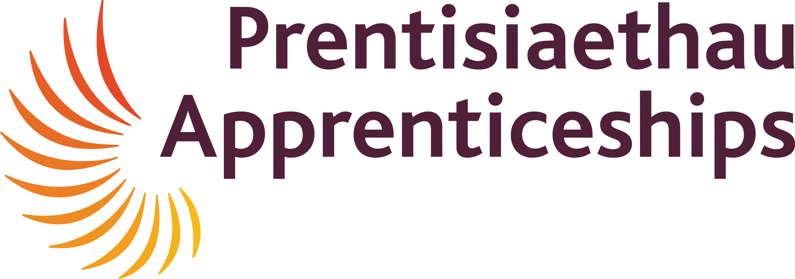
Apprenticeship Matching Service - AMS
The apprenticeship matching service provides a FREE
online platform to advertise and promote your quality
apprenticeship job opportunities.

This enables thousands of potential Apprentices throughout Wales to search and apply for your vacancies.

This online service allows you to:
- View all your applicants
- Shortlist and organise pre-interview screening
- Send invitations for interview
- Accept and reject applicants; all online

As your Apprenticeship Training Provider, we will also work with you to ensure we maximise the impact and reach of your advert has by offering the following services;

- Posting your opportunity on our social media platforms Facebook, Twitter & LinkedIn
- Build a unique and branded advert using logos and guidance supplied

If you are interested in using this FREE online tool, please complete the form below and return to our Marketing Assistant, Kim Williams who will be in touch soon; kim.williams@cambriantraining.com

Information required;

Employer Name
Location
Exclude the Employers’ Name From Advert | Yes/No* *Please delete
Have you used this service before for Apprenticeships or JGW | Yes / No* *Please delete
Vacancy Title
Occupation
Sector
Vacancy Description
Hours of Work
Pay details
Number of Opportunities
Training to be provided | On the job training to be provided
Closing Date for Application
Start Date
Interview Arrangments | To be made directly with the employer
Desirable Personal Qualities
Qualifications Needed
Minimum Age
Welsh Language Requirements | Welsh Spoken Skills: Yes/No*  Welsh Written Skills: Yes/No* *Please delete
Provider Name | Cambrian Training Company
Course  Apprenticeship Title | [Please discuss with a member of our team to ensure the course meets both the individuals and business needs]
Apprenticeship Level | [Please discuss with a member of our team to ensure the course meets both the individuals and business needs]
Employer Contact
Contact Email address
Contact Phone Number
Date of request
As an employer working in partnership with CTC please tick the following box if you would like to recieve our quarterly newsletters that will keep you up to date with important news and support we can offer you with regards to training, development and apprenticeships.
CTC Internal use only:
Date Recieved |  | Date sent to Careers Wales |  | Date went live
Date Filled |  | Number of Applications |  | Period open

