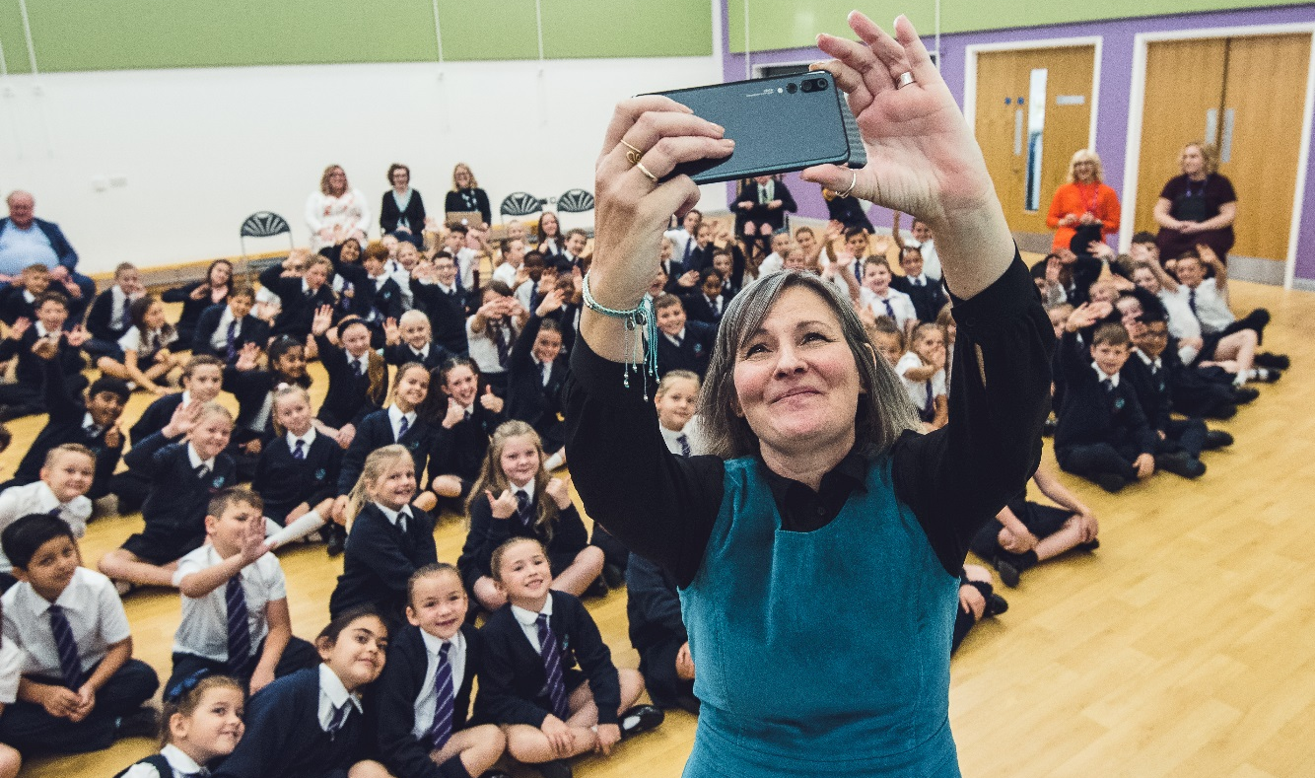
Children’s Laureate Wales launch at Jubilee Park Primary School, Newport © Camera Sioned | Literature Wales
Apprentice Bookkeeper
16-month fixed term contract, part-time (20 hours/week),
To start as soon as possible and by 26 February at the latest.
Includes fully funded AAT Accountancy Level 2 or 3 training and qualification and a leased laptop.
Salary: £20,000 - £24,950 pro rata (depending on experience)
Location: Wales (position is entirely home-working)
Closing Date: Wednesday 10 February, 5.00 pm Interviews: Monday 15 February 2021

Literature Wales – About us
Literature Wales is the national company for the development of literature. Our vision is a Wales where literature empowers, improves and brightens lives. Our aim is to inspire communities, develop writers, and celebrate Wales’ literary culture.
We are a member of the Arts Council of Wales’ Arts Portfolio and are one of eight National Companies which also includes the BBC National Orchestra Wales, Ffilm Cymru Wales, National Dance Company Wales, National Theatre Wales, Theatr Genedlaethol Cymru, Wales Millennium Centre and Welsh National Opera. Literature Wales works in Welsh, English and bilingually across Wales. We have offices in Llanystumdwy and Cardiff. Our patron is Sir Philip Pullman.

A day in the life of the Apprentice Bookkeeper
During your working day you will multitask; from processing purchase invoices for payment and entering sales receipts onto the accounting software (Quickbooks), to raising sales invoices and recording payments.
Some days, you will support the Finance Executive with monthly and quarterly reporting as well as preparing for the annual audit, or assist the Corporate Manager with additional operational duties.
On other days you will work on your current AAT Accountancy module with your tutors, complete the latest exam, or engage in a review meeting with your line manager and tutors.
We are a friendly, creative and committed team that works in Welsh, English and bilingually across Wales. Our offices are based in Llanystumdwy and Cardiff, but we are currently working entirely from home and will continue to do so for the foreseeable future.
About the Role
The Apprentice Bookkeeper will work from home throughout the duration of the role, although they will be required to attend a test centre to complete the unit tests within the qualification.
You will be responsible for ensuring that all transactions (made and received) are correctly entered into the accounting system and supporting colleagues in accurate project budgeting and accounts. You will also support the implementation of new internal controls and developments to Literature Wales’ financial operations.
You will receive one day of AAT accountancy training a month with our partners Cambrian Training and Peak Accountants and complete the assignments and associated qualification examinations at the end of each module. These will all be delivered digitally, free of charge to you, but must be completed outside your working hours.
The Apprentice Bookkeeper will:
- Record all receipts received e.g. card transactions via Worldpay and PayPal, BACS receipts and cheques paid in;
- Process all purchase invoices received and ensure they have the relevant approvals;
- Prepare batches of purchase invoices for fortnightly payment runs and record them once approved;
- Raise and send sales invoices as requested;
- Enter all credit card charges for reconciliation;
- Support the Finance Executive with monthly and quarterly reporting;
- Support the Corporate Manager in operational matters;
- Any other tasks as required by the organisation.
Reporting to:
- Finance Executive
Suitability for the role
The successful candidate will have the following characteristics, skills and experiences:
- Identify with one or more of the following:

- I come from a Black, Asian or Minority ethnic background
- I am disabled or suffer from long-term illness
- I come from a low-income background

- Speak Welsh or have a positive attitude towards the Welsh language
- Be of any age and a permanent resident of anywhere in Wales
- Access to broadband and a home environment which is conducive to working (this can be discussed if it is a problem)
- The flexibility to occasionally work unsociable hours
- GCSE or equivalent in Maths at grade C or above
- Attention to detail and the ability to work well under pressure and to deadlines (e.g. year-end reporting)
- A willingness and ability to learn new skills and concepts
- Digital literacy, especially in the use of Microsoft Excel and Office
- Strong, sensitive and positive communication skills
- The ability to think creatively and enjoy collaboration and working outside of the usual confines of the role
- Experiences of working, volunteering or learning which required you to use or demonstrate the skills outlined above – these do not have to relate to bookkeeping.

Please note that you cannot apply for this role if you already have an AAT Accountancy qualification, or equivalent, at Level 3 or higher. Previous paid employees of Literature Wales from the past six months are also ineligible to apply (but anyone employed on a freelance basis or awarded an artistic commission can apply).

How to apply

- Please read the above job description and suitability list carefully. Also, please read the Literature Wales Strategic Plan for 2019-2022 here and our 2019-2022 Mid-Term Report here.

- Please write an application letter of no more than 2 pages of A4 or create a video application of no more than 5 minutes (both formats are acceptable and of equal value). Please let us know why you are interested in the role, and how you are suitable for it e.g. tell us about your experience or qualifications and what interests you about specific elements of the role. Please also tell us about you and your life ambitions e.g. what excites you and what would you like to be doing in five years-time?

- Send the following to post@literaturewales.org by 5.00 pm on Wednesday 10 February 2021:
- Your application letter or video;
- Your CV (of no more than three A4 pages) and the details of two referees who know you in a professional context (this could be a former teacher). We will only contact referees after an offer of employment has been accepted;
- A completed Literature Wales Equality and Diversity Form (available here).
What will happen next?
We will assess the applications and invite successful candidates to a digital interview on Monday 15 February. There will be two people on the interview panel representing the Literature Wales staff. A short task will follow the interview, and the task outcome will be assessed alongside the interview. Although this will be a formal interview, we will try to ensure that each candidate is comfortable with the interview process. If the interview process causes you any concern, please let us know in advance

and we can arrange an informal meeting or chat over telephone or video call with Emma Richards, Finance Executive, before the interview.
Please feel free to contact us to discuss the role in advance, or to ask for more information. To speak with Emma Richards directly or to arrange a call back, please e-mail her at emma@literaturewales.org
We will contact all the candidates with the outcome of the interviews by Wednesday 17 February.

Our recruitment policy
Literature Wales benefitted from being a part of the Weston Jerwood Creative Bursaries, which support arts organisations to expand their approach to diverse recruitment and talent development. We are committed to welcoming candidates from a wide range of backgrounds, which includes assessing applications partly based on potential strengths. If you would like to apply for this role but are uncertain whether you have sufficient experience, please contact us for an informal chat.

Literature Wales is a registered charity that works with the support of the Arts Council of Wales and the Welsh Government. This role is offered through the Welsh Government funded Apprenticeships Programme in Wales.

